RINGS: LEVEL 1 If a survey were given across the world asking what the most common piece of jewelry is, the answer would likely be the ring. As an object the ring transcends cultures and societies. It may vary in its meaning, significance and form, but it nevertheless appears everywhere.

For this assignment you will make a variety of rings graded on meeting the given criteria and having refined craftsmanship. The rings will increase in complexity and your skills will build as you closely follow each demonstration. As a starting point, rings will also teach and remind students how to safely use the equipment and tools. It is important to follow demonstrations closely and do steps in the correct order.

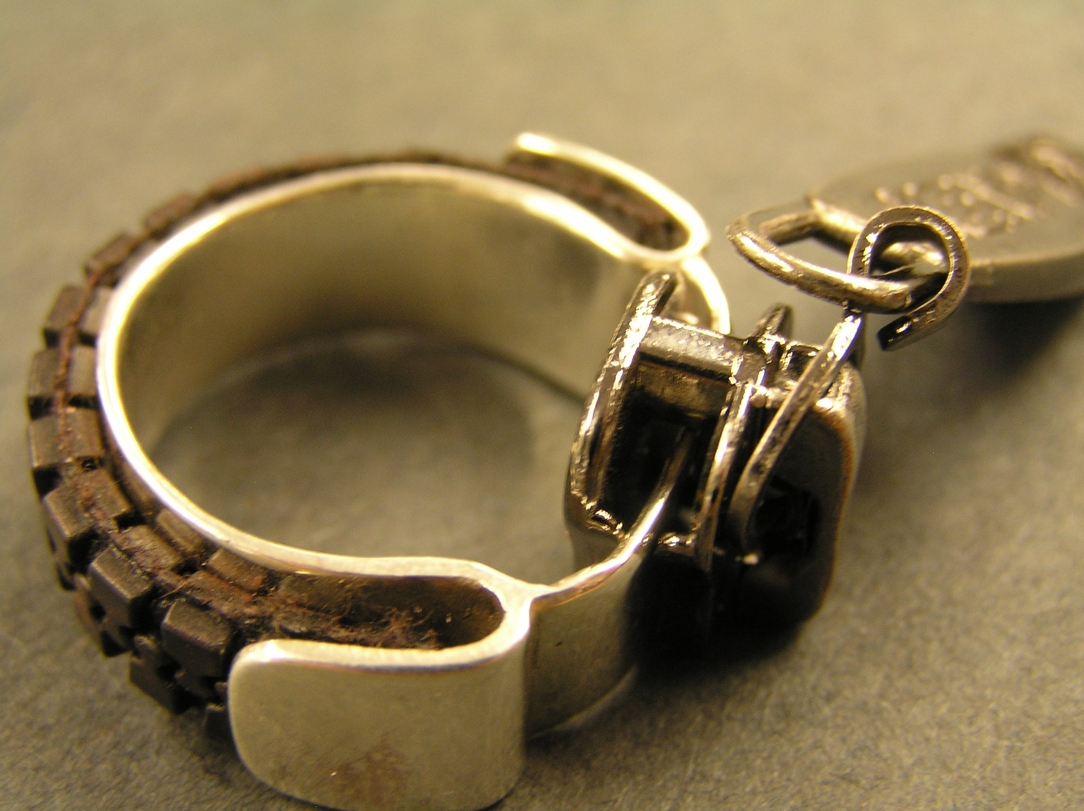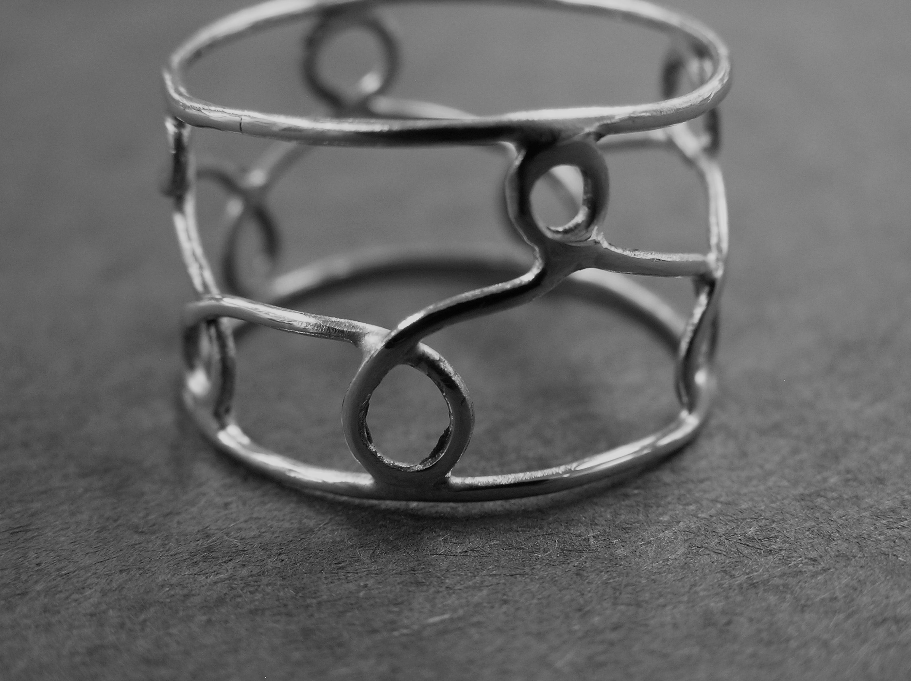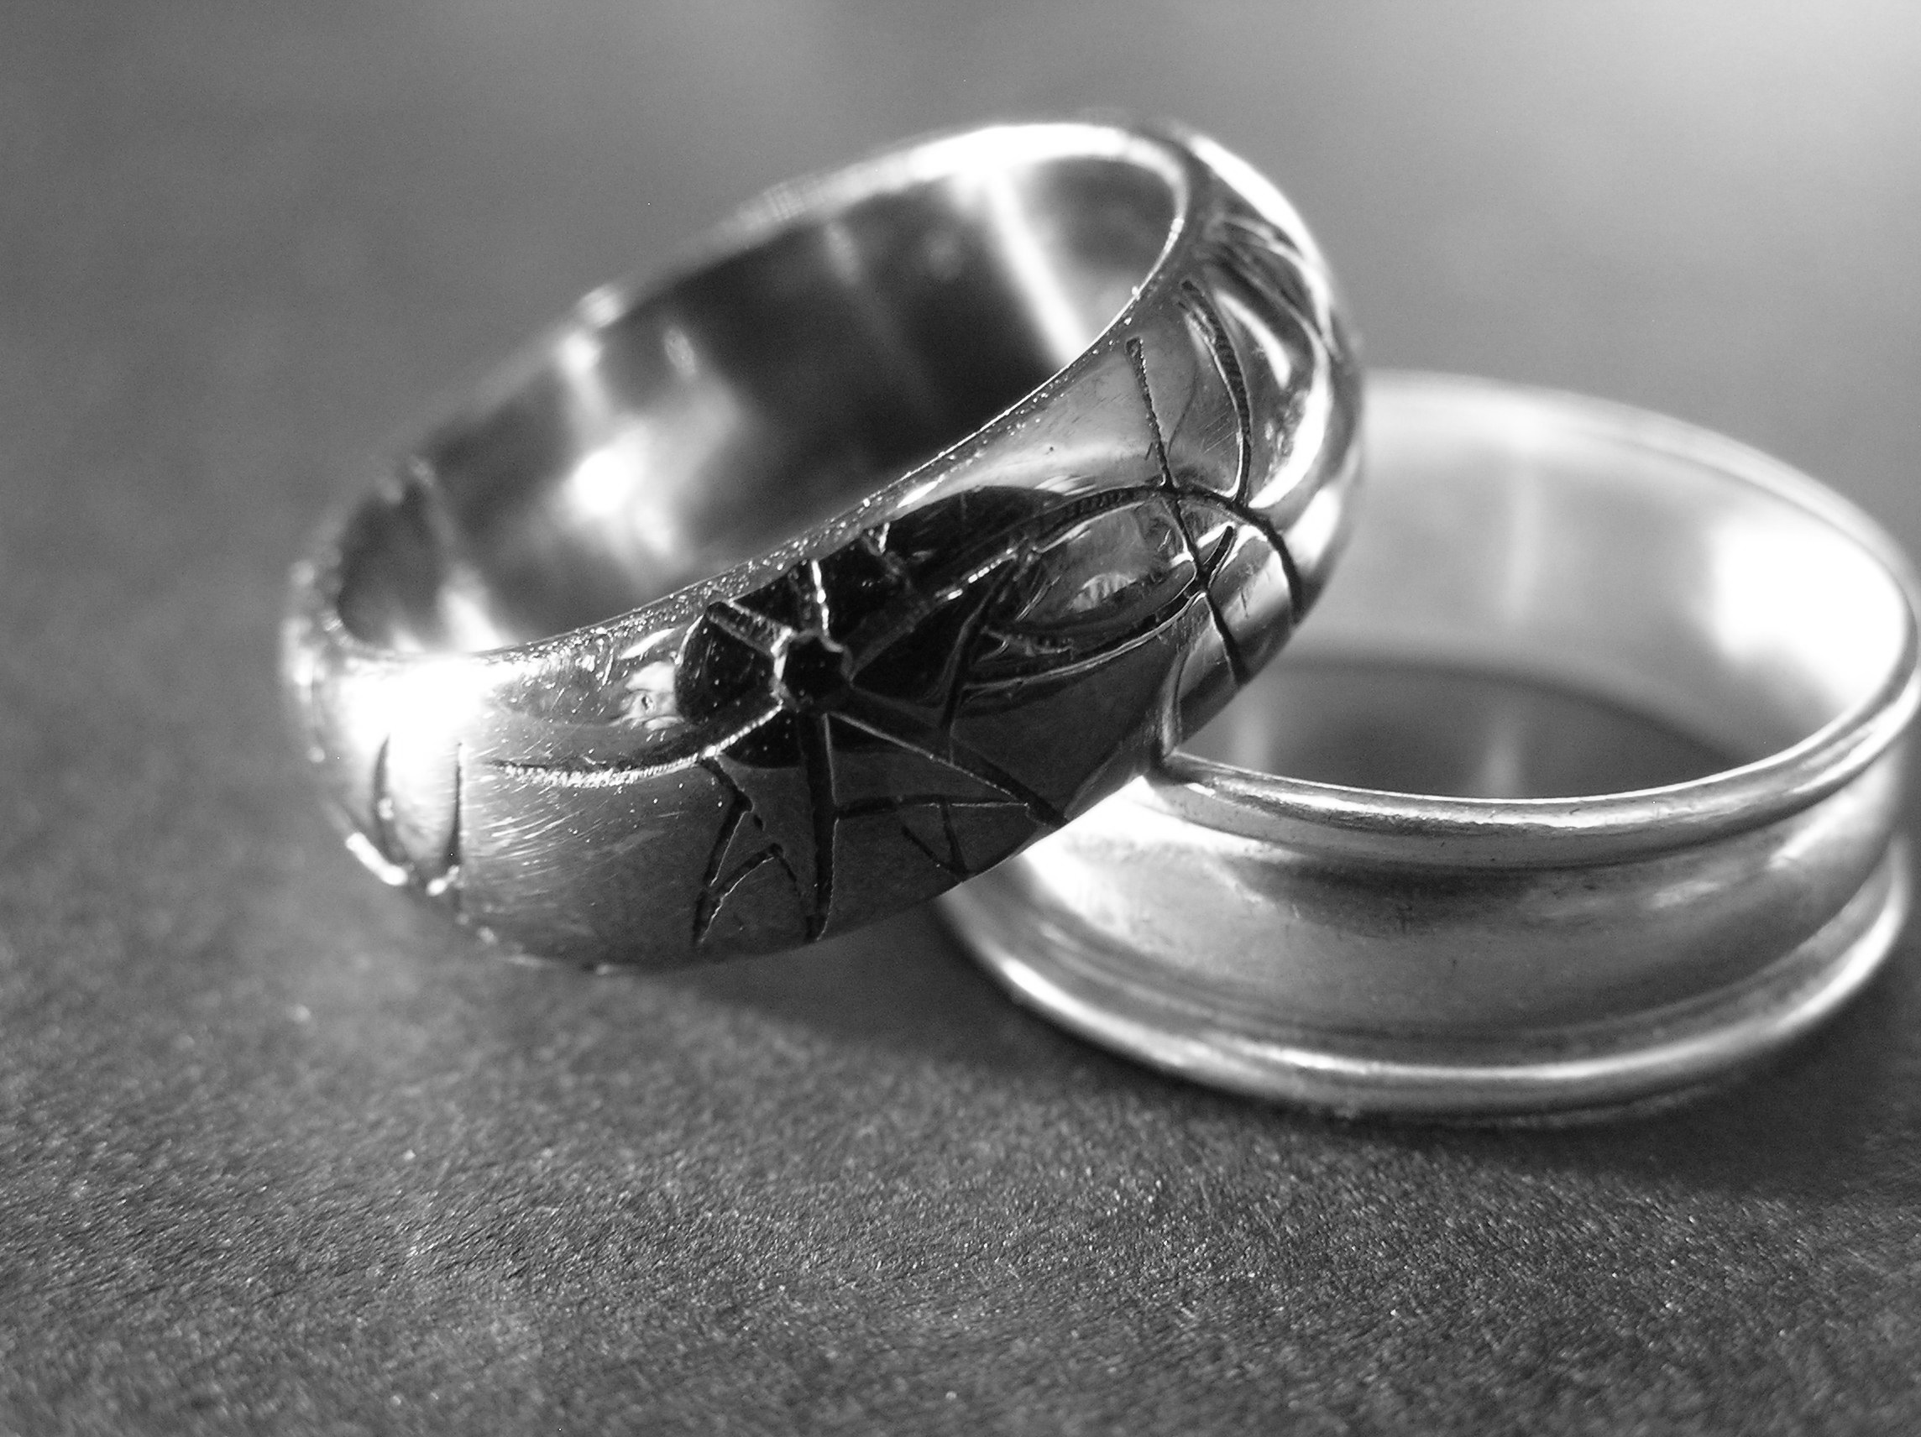

Brainstorm: Together with your tablemates list as many different types of “rings” as you can. Think outside the box but try not to repeat (different names for the same thing). The table with the most will win a small prize - Everyone should write on their own paper.

Level 1 Rings: Criteria and Craftsmanship

Simple Brass Band: (The 10 step ring) ( /50 points)
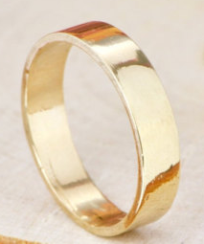
- Fit: left ring finger

- Initials clearly stamped on the inside or outside of the ring (avoid
double stamping or overly sanded letters)
- Invisible solder join
- Even outer edge (fully filed, sanded, buffed & polished)
- Filing & Cross-Filing (Remove all silver solder & avoid deep
gouges)
- ALL SURFACES Sanding & Cross-Sanding (Remove all file marks and scratches) 280, 400, 600, wet 600
- Buff & Polish = HIGH SHINE (clean off all compound)

Silver Dome + Word: (The 10 step ring) ( /50 points)
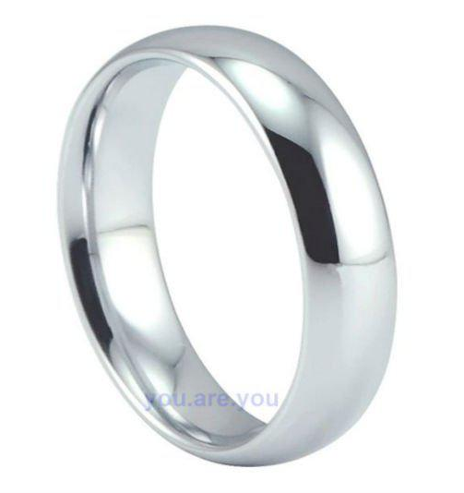
- Fit: Any finger or anyone

- Poetic and interesting word clearly stamped on the inside
(word is aligned and readable- avoid double stamping or overly
sanded letters)
- Invisible solder join (minimal filing inside and outside)
- Band is even, keep the contour and complex curve
– No thin or flat parts at the join
- TIP: DO NOT FILE THE OUTER EDGES OF THIS BAND!
- All surfaces Sanded & Cross-sanded (280, 400, 600, wet 600)
- Buff & Polish = HIGH SHINE & Clean off compound
- Smooth edges and no visible scratches

The Love “Knot: Ring: (Follow the steps on the demonstration board)
( /50 Final Ring) ( /20 points Practice Ring)
- Fit: Intended size for any finger or anyone

- Complete a brass practice ring (Steps 1-15)
- Complete a nickel silver final ring
- Tight knot without gaps or visible solder on the knot
- Two visible wires along the band
(not filled with solder or filed flat)
- Invisible join, filed and sanded (just enough- No thin or flat spots
at join)
- Band is even and lays flat on the table without wobbles
- All surface are Sanded & Cross-sanded (280, 400, 600, wet 600)
- Buffed and polished to a HIGH SHINE (clean off all compound)
- No visible scratches

GRADE SHEET Simple Brass Band: (The 10 step ring) ( /50 points)
- Fit: left ring finger

- Initials clearly stamped on the inside or outside of the ring (avoid
double stamping or overly sanded letters)
- Invisible solder join
- Even outer edge (fully filed, sanded, buffed & polished)
- Filing & Cross-Filing (Remove all silver solder & avoid deep
gouges)
- ALL SURFACES Sanding & Cross-Sanding (Remove all file marks and scratches) 280, 400, 600, wet 600
- Buff & Polish = HIGH SHINE (clean off all compound)

3-D Design, Ms. Ferrell Name:
Rings: Level 1 Period:

GRADE SHEET Simple Brass Band: (The 10 step ring) ( /50 points)
- Fit: left ring finger

- Initials clearly stamped on the inside or outside of the ring (avoid
double stamping or overly sanded letters)
- Invisible solder join
- Even outer edge (fully filed, sanded, buffed & polished)
- Filing & Cross-Filing (Remove all silver solder & avoid deep
gouges)
- ALL SURFACES Sanding & Cross-Sanding (Remove all file marks and scratches) 280, 400, 600, wet 600
- Buff & Polish = HIGH SHINE (clean off all compound)

3-D Design, Ms. Ferrell Name:
Rings: Level 1 Period:

GRADE SHEET Simple Brass Band: (The 10 step ring) ( /50 points)
- Fit: left ring finger

- Initials clearly stamped on the inside or outside of the ring (avoid
double stamping or overly sanded letters)
- Invisible solder join
- Even outer edge (fully filed, sanded, buffed & polished)
- Filing & Cross-Filing (Remove all silver solder & avoid deep
gouges)
- ALL SURFACES Sanding & Cross-Sanding (Remove all file marks and scratches) 280, 400, 600, wet 600
- Buff & Polish = HIGH SHINE (clean off all compound)

GRADE SHEET Silver Dome + Word: (The 10 step ring) ( /50 points)
- Fit: Any finger or anyone

- Poetic and interesting word clearly stamped on the inside
(word is aligned and readable- avoid double stamping or overly
sanded letters)
- Invisible solder join (minimal filing inside and outside)
- Band is even, keep the contour and complex curve
– No thin or flat parts at the join
- TIP: DO NOT FILE THE OUTER EDGES OF THIS BAND!
- All surfaces Sanded & Cross-sanded (280, 400, 600, wet 600)
- Buff & Polish = HIGH SHINE & Clean off compound
- Smooth edges and no visible scratches

3-D Design, Ms. Ferrell Name:
Rings: Level 1 Period:

GRADE SHEET Silver Dome + Word: (The 10 step ring) ( /50 points)
- Fit: Any finger or anyone

- Poetic and interesting word clearly stamped on the inside
(word is aligned and readable- avoid double stamping or overly
sanded letters)
- Invisible solder join (minimal filing inside and outside)
- Band is even, keep the contour and complex curve
– No thin or flat parts at the join
- TIP: DO NOT FILE THE OUTER EDGES OF THIS BAND!
- All surfaces Sanded & Cross-sanded (280, 400, 600, wet 600)
- Buff & Polish = HIGH SHINE & Clean off compound
- Smooth edges and no visible scratches

3-D Design, Ms. Ferrell Name:
Rings: Level 1 Period:

GRADE SHEET Silver Dome + Word: (The 10 step ring) ( /50 points)
- Fit: Any finger or anyone

- Poetic and interesting word clearly stamped on the inside
(word is aligned and readable- avoid double stamping or overly
sanded letters)
- Invisible solder join (minimal filing inside and outside)
- Band is even, keep the contour and complex curve
– No thin or flat parts at the join
- TIP: DO NOT FILE THE OUTER EDGES OF THIS BAND!
- All surfaces Sanded & Cross-sanded (280, 400, 600, wet 600)
- Buff & Polish = HIGH SHINE & Clean off compound
- Smooth edges and no visible scratches

GRADE SHEET The Love “Knot: Ring: (Follow the steps on the demonstration board)
( /50 Final Ring) ( /20 points Practice Ring)
- Fit: Intended size for any finger or anyone

- Complete a brass practice ring (Steps 1-15)
- Complete a nickel silver final ring
- Tight knot without gaps or visible solder on the knot
- Two visible wires along the band
(not filled with solder or filed flat)
- Invisible join, filed and sanded (just enough- No thin or flat spots
at join)
- Band is even and lays flat on the table without wobbles
- All surface are Sanded & Cross-sanded (280, 400, 600, wet 600)
- Buffed and polished to a HIGH SHINE (clean off all compound)
- No visible scratches

3-D Design, Ms. Ferrell Name:
Rings: Level 1 Period:

GRADE SHEET The Love “Knot: Ring: (Follow the steps on the demonstration board)
( /50 Final Ring) ( /20 points Practice Ring)
- Fit: Intended size for any finger or anyone

- Complete a brass practice ring (Steps 1-15)
- Complete a nickel silver final ring
- Tight knot without gaps or visible solder on the knot
- Two visible wires along the band
(not filled with solder or filed flat)
- Invisible join, filed and sanded (just enough- No thin or flat spots
at join)

