Key 3D Printing Terminology (8K Mega Sonic Phrozen Resin Printer)

3D Modeling
3D modeling is the process of developing a digital depiction of a three dimensional object using computer aided design software. Without a 3D model there can be no 3D print. See also CAD.

CAD
Short for Computer Assisted Design. CAD is the use of computer software to produce a digital design in either two or three dimensional formats that can then be used to print a physical object.

Cartesian Coordinates
A system of coordinates along three axes representing length, width and height and expressed as x, y and z. Cartesian coordinates are used by 3d printers to move through three dimensions while printing an object.

Photopolymer (Resin)
A material (like liquid resin) used in 3d printing that hardens when exposed to certain types of light.

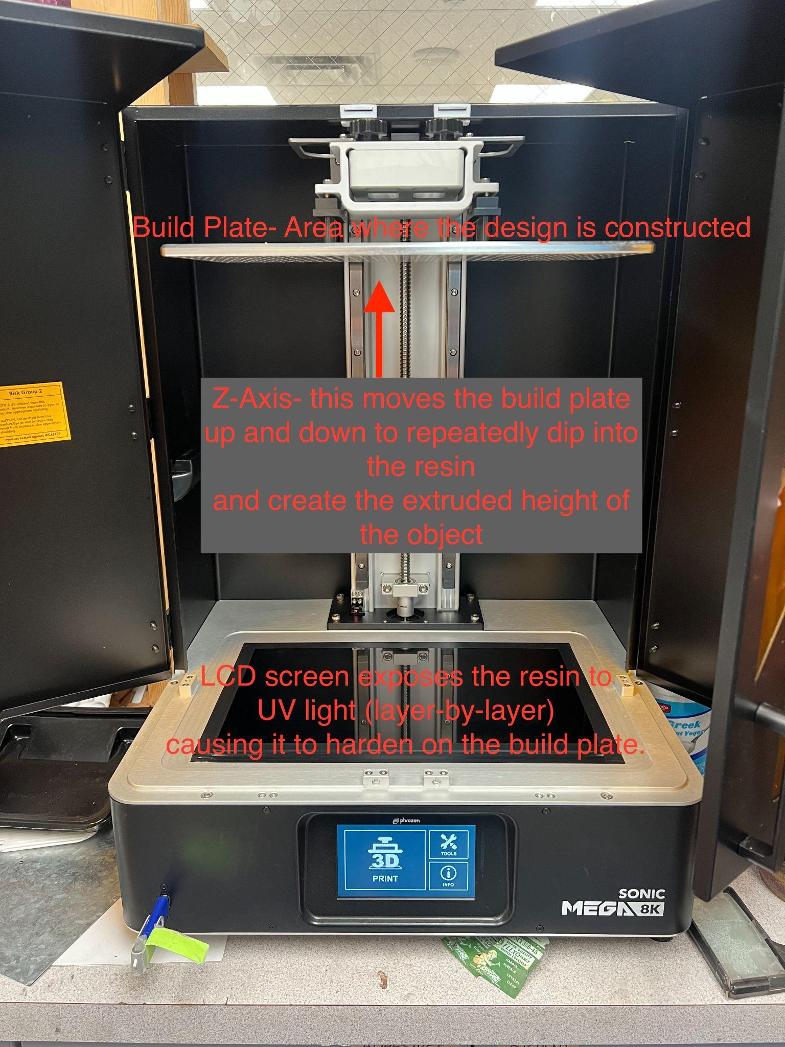
3D Printer
A machine that produces a three dimensional object one layer at a time. Filament-based starts with a roll of thin thermoplastic thread and fuses it layer by layer to build an object; whereas a Resin-based printer dips into a vat of liquid resin and fuses the design layer-by-layer using UV light.

Bed or Build Plate
Made of perforated aluminum and connected to the Y-Axis of the machine. It dips repeatedly into the resin and creates the surface where the 3-D object is printed.

LCD Screen
The glass surface, a UV light is programed (by the slicer software) to expose the resin, hardening the resin one layer at a time.

Z-Axis
Z-axis in 3D printing coordinates are typically oriented vertically, and coordinate with the height of the object in the chamber.

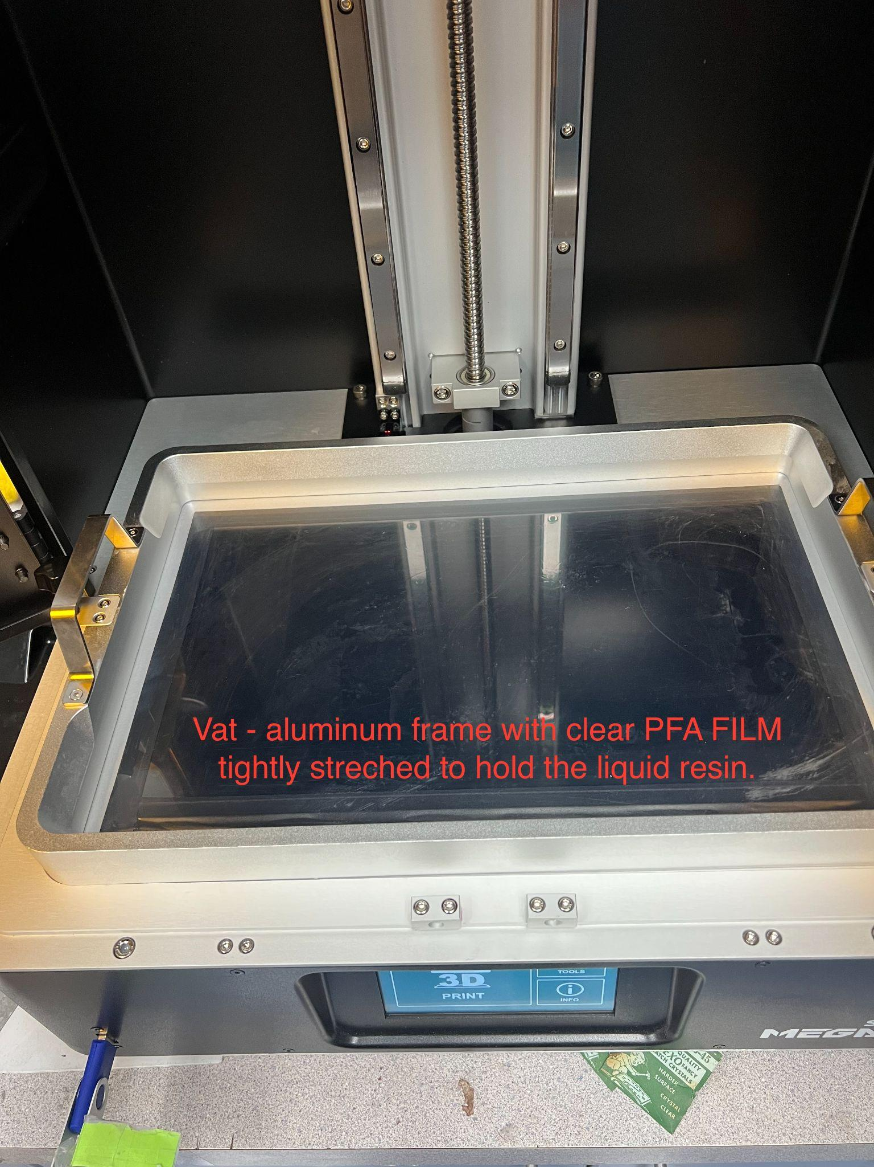
X-Axis
A part of the Cartesian coordinate system, the x-axis represents left to right horizontal printing movement.

Y-Axis
A part of the Cartesian coordinate system, the y-axis represents front-to-back horizontal printing movement.

Vat
Aluminum frame with clear PFA Film tightly stretched to hold the liquid resin, allowing the exposure light to pass through and harden the resin with each layer

Enclosure
A part on a 3D printer that protects the user from moving parts and high-temperature objects. Is also used to increase or stabilize the ambient air temperature around the print to stop warping or cracking of the print, caused from cooling too fast.

Design Tips and Troubleshooting: We are using OnShape (free web-based software)

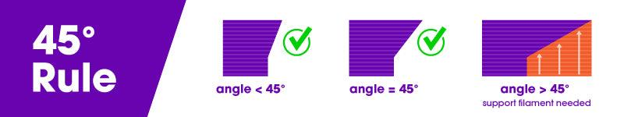

45° Rule
A general rule used in 3d modeling that advises against designing objects that contain angles greater than 45° unless a support material is used. See also Bridge, Chamfer, Overhang and Support Materials.

Chamfer/Fillet
A 3d modeling term that describes a symmetrical, sloping (fillet-angled bevel) or curving (chamfer) surface at an edge or corner that is used to avoid violating the 45° rule.

Bridge
A 3d modeling term to describe a horizontal overhang placed between two vertical supports.

Overhang
Any part of a 3d model that lacks support below it. Parts that protrude at angles greater than 45° are generally considered overhangs. See also Support Materials and Support Structures.

Perimeter
A slicer program setting. Perimeter refers to the thickness of the walls or shell of a printed object. The greater the number of perimeters, the thicker the shell of the object will be.
Lift and Rotate

Shell
The outer wall of a designed object. A slicer program setting can adjust the shell thickness refers to the number of layers that the outer wall will have before infill printing will begin. The higher the setting is for shell thickness, the thicker the outer walls of your object will be.

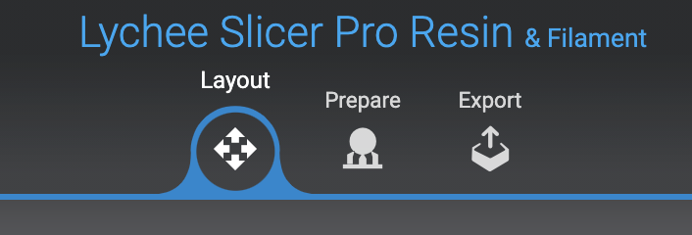
PREPARING THE OBJECT FOR PRINTING (Lychee Slicing Software)
Export the file from OnShape (CAD software) and open the file in Lychee (Slicer software)

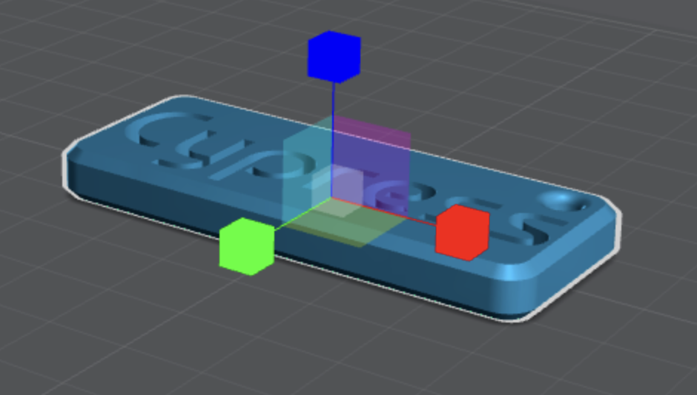
Scale Tool (type in the original dimensions)
You may need to resize your object (sometimes it imports in mm instead of inches)
Move Tool (lift or float your object off the design x and y axis into the z axis)
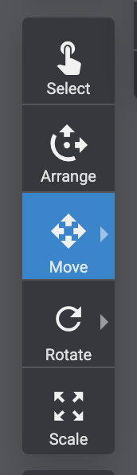

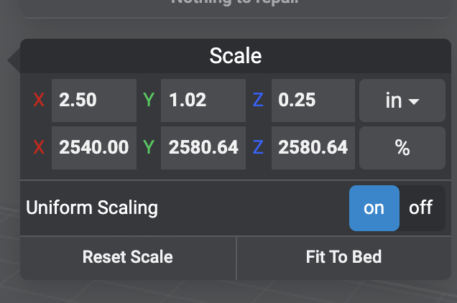
Rotate Tool
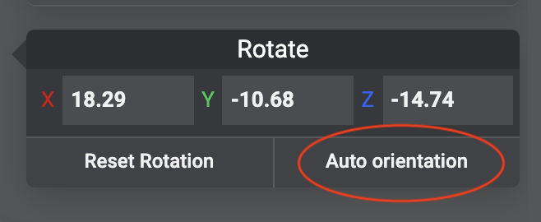
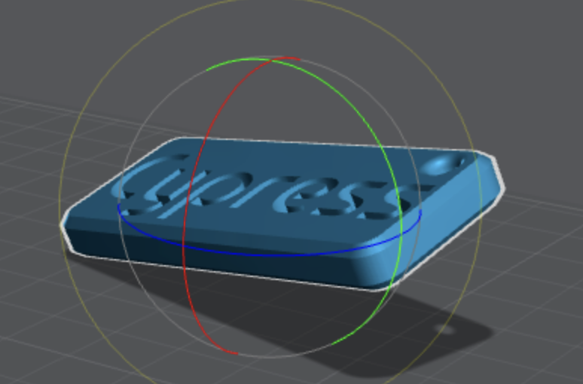
You need to orient your object at an angle along both the x and y axis to allow for proper drainage and to avoid suction

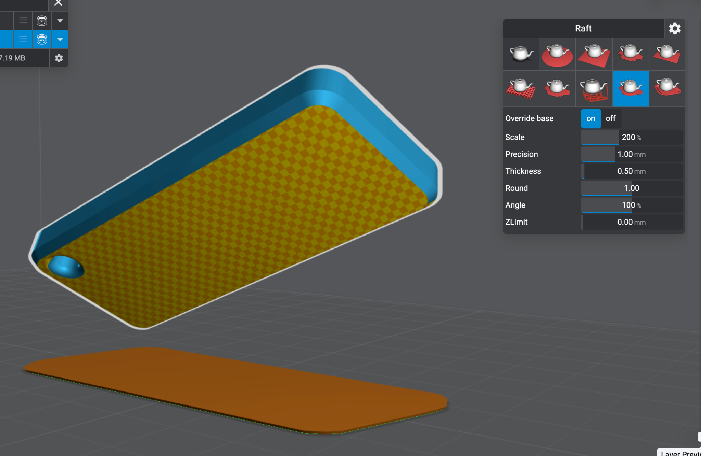
Raft
A raft is a layer or layers of extruded thermoplastic that is used to stabilize a printed object. A raft helps an object to adhere to the print bed. Unlike a brim, a raft is connected to the perimeter and bottom of an object.

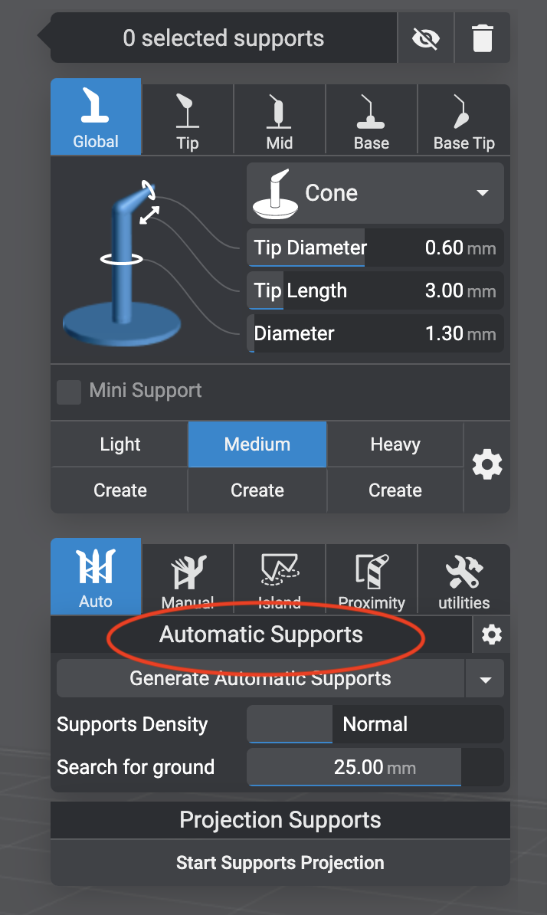

Supports
Vertical elements that connect the object to the raft (similar to casting sprues) provide support and are essential to a successful print. If the object becomes disconnected, the exposed resin will float in the vat rather than build up the object.
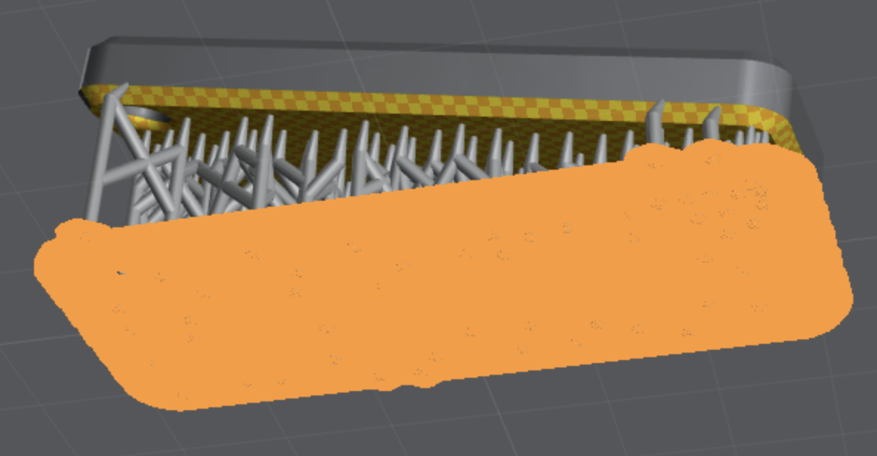
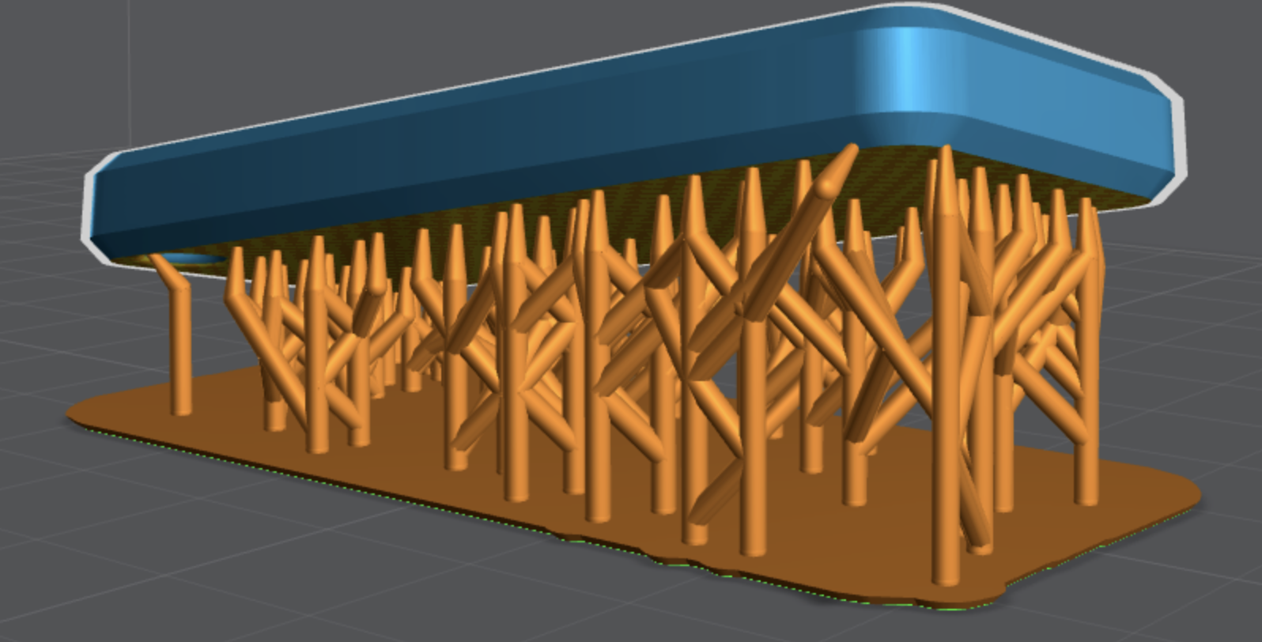

Export the File (save to the flashdrive) for the 3-D printer to read and print all the information

Slicer
A 3D slicer is a piece of 3D printing software that takes a digitized 3D model and converts it into printing instructions that your printer can then use to turn the model into a physical object. In essence, the slicer takes the CAD model and “cuts” it into horizontal layers (called slices). mEach slice contains coordinates for printing locations on the build surface, as well as instructions as to layer height, shell thickness and more.

It then calculates how much material needs to be used for that layer, where the material should go and how long it will take. It then converts all of the information for each layer into one GCode file which is sent to your printer.

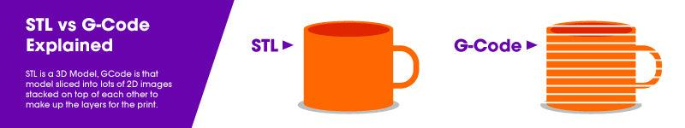

GCode
A program language that controls the actions of a 3d printer – things like motion, speed, rotation and depth. Commonly, this code is generated by a slicer program. See also Slicer.

OBJ
Short for Object File. A 3d file format used by CAD programs as an alternative to STL files when information about color or material is important.

STL
A 3D file format used by CAD programs. You can use an STL editing software to edit and optimize them.mb

DLP
Short for Digital Light Processing. A form of 3D printing where a light source is used to cure photopolymer resin to produce a printed object.

Print Resolution (8K)
An indication of printing quality. Horizontal resolution refers to the movements made by the print head along the x and y axes. The smaller the movements, the higher level of printing detail the printer produces.
Vertical resolution refers to movements by the print head along the z axis. The smaller these movements, the smoother the finished surface of the printed object. See also Layer Height.

Print Speed
A slicer program setting,optimal speed depends on the object you are printing and the material that you are using to fabricate the object. In general, simple objects with less detail can be printed faster without complication.

Troubleshooting

Cracking
A 3D printing defect. Cracking occurs when one layer of print material bonds inadequately with another layer. When this happens, as the object cools, a split or crack occurs between the two inadequately bonded layers. See also Splitting.

Fill Density
A slicer program setting that is a measure of how much material will be printed inside the outer shell of the object in question. Infill density is used to conserve filament while printing and speed up printing times. More information on slicer program settings can be found here.See also Slicer.
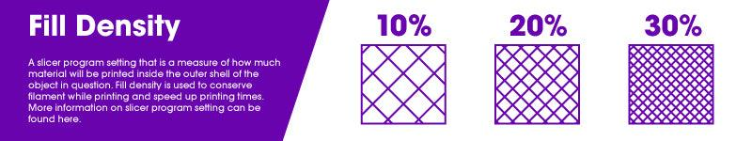

Suction
If an object is not oriented with enough of an angle or drainage, it can create a suction on the build plate that is strong enough to detach the supports while printing, resulting in a failed print. Additionally, if an object is not oriented with enough of an angle, the resin doesn’t drain off causing a bumpy surface.

Curing/Hardening

The process of using UV light to harden a 3d printing material to its final form. The print is removed from the build plate, supports and raft are removed, the object is thoroughly cleaned in the ultrasonic wash, then rinsed and dried using compressed air. The object is then placed in the UV Curing machine for a select period of time to fully harden the object.

Warping
A 3d printing defect. Warping occurs when an object is cooling after printing. Cooling causes contraction and this contraction causes stress along the object’s lateral surfaces. The quicker the cooling occurs, the greater the stress on the object.
This stress is greatest at corners where two sides meet. There, the pulling stress exerted on both sides causes the corner of the object to deform and pull up and inward. The result is not pleasing to the eye and usually makes the object unusable. You can learn more about warping and how to correct it here.

